Second Semester Examination -2011
Higher National Diploma in Information Technology –First Year

IT2004 - Introduction to Data Communication and Networks

Marking Scheme
No of pages: 17
Q1)
.
  - Define Analog and digital signal. [ 2 Marks]
Analog - Signal intensity varies continuously over time.
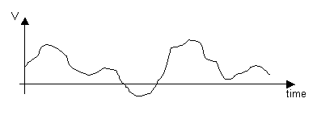
Digital - Signal intensity is constant for some period of time and then changes to another constant value. This transition takes place in a very short time.

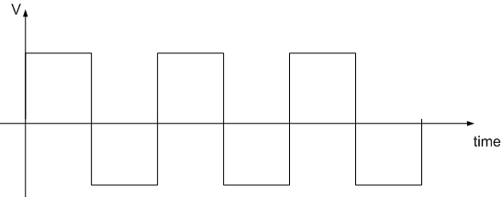

  - Briefly describe the three characteristics of a sine wave. [ 6 Marks]
Peak Amplitude - The maximum value / strength of the signal over time
Frequency - Frequency is the rate at which the signal repeats. Expressed in Hertz (Hz), or cycles per second
Phase - Describes the position of a wave relative to time zero, (phase angle θ is expressed in degrees or radians)
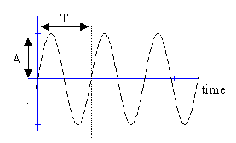
  - What is the relationship between period and frequency?
F=1/T [ 2 Marks]
  - What is the bit rate for the signal in below?

16 nanoseconds

•••
Time

[ 4 Marks]
Bit rate =$\frac{8}{16 ×{10}^{-9}}$ = 5 $×$ 10⁸ bits per second
  - Draw a frequency domain representation of the signal shown in below? [ 6 Marks]

7 microseconds

5

Time
Number of circles = 14
Period of the wave = 7/14 ms =0.5 ms = 5 $×$10⁻⁴ s
Frequency of the wave = 1 / 5 $×$10⁻⁴ = 2 $×$ 10³ =2 kHz
Frequency (kHz)
Amplitude (Volts)
1 2 3 4 5
5

Q2)
- Explain the difference between Client-Server and Peer-to-Peer networks.
[4 Marks]
Peer-to-Peer
  - Easy to install and configure.
  - No dedicated server required.
  - Users control their own resources.
  - Inexpensive to purchase and operate.
  - No specialist software required.
  - No dedicated administrator to run the network required.
  - Difficult to employ security.
  - Too many passwords for shared resources.
  - Backups difficult to manage.
  - No centralization.
  - Limited users.
Client-Server
- Centralized user accounts, security and access controls simplify network administration.
- More powerful equipment means more efficient access network resources.
- Single password login, means access to all resources.
- Supports greater numbers of users, or networks where resources are heavily used
- More costly to install and maintain.
- Single point of failure, server goes down, the network goes down.
- Complex special-purpose software requires appointment of expert staff, increasing costs.
- Dedicated hardware and software increases costs.

- For each of the three main physical network topologies (i.e. bus, ring, star), list two advantages and two disadvantages of each of them. [6 Marks]
Bus
Advantages
- Low cost
- Easy to connect a computer or peripheral to bus.
- Requires less cable length than a star topology.
- No need to purchase any additional devices such as switch and hub.
Disadvantages
- Entire network shuts down if there is a break in the main cable.
- Terminators are required at both ends of the backbone cable.
- Difficult to identify the problem if the entire network shuts down. (Difficult to troubleshooting).
Ring
Advantages
- It is less expensive than star topology.
- Nodes can be easily added or removed.
Disadvantages
  - It is more difficult to install and maintain.
  - If a node fails, it affects the entire network.
Star
Advantages
- It is easy to install and to maintain.
- Can easily add and remove nodes to and from the network without affecting the network.(scalability)
- If need to add another workstation with a star topology we can simply connect that system an unused part of the hub.
- If any node fails, other nodes are not affected.

Disadvantages
- This type of network depends upon the central Hub. If Hub fails the entire network is failed.(But hub troubleshooting is easier than bus topology)
- Each computer is directly connected to the Hub through a cable, so it becomes more costly.
- Give a brief description of the steps followed by a host in accessing a CSMA/CD & Token Passing network. [10 Marks]
CSMA/CD
- Only when a computer "senses" that the cable is free and that there is no traffic on the cable can it send data.
- Once the computer has transmitted data on the cable, no other computer can transmit data until the original data has reached its destination and the cable is free again.
- If two or more computers happen to send data at exactly the same time, there will be a data collision.
- When that happens, the two computers involved stop transmitting for a random period of time and then attempt to retransmit.
- Each computer determines its own waiting period; this reduces the chance that the computers will once again transmit simultaneously.

Token Passing
- A special type of packet, called a token, circulates around a cable ring from computer to computer.
- When any computer on the ring needs to send data across the network, it must wait for a free token.
- when a host want to transmit data, it should hold the token, which is an empty packet.
- The token is circling the network in a very high speed.
- If any workstation wants to send data, it should wait for the token.
- When the token has reached the workstation, the workstation can take the token from the network, fill it with data, mark the token as being used and place the token back to the network.

Q3)
- List the physical components required to set up a cost effective peer-to-peer LAN.
[4 Marks]
- Personal Computers equipped with Network Interface cards and, a network enabled Operating system (e.g. Win 95/98/2000/XP/7, etc.)
- Cables and Connectors. (e.g. Straight Through cables, RJ45 connectors)
- Hub.
- What is the major operational difficulty in the above type of LAN? [2 Marks]
- no centralized management is possible.
- security is very low.
- What are the additional elements needed to convert this into a server based LAN?
[2 Marks]
- A Computer to function as a server.
- Network Operating system software.(e.g windows server 2003/2008)
- Suppose the performance of this LAN degrades. What would be the most probable single physical component that may be responsible for this degradation? Suggest a better choice for the component. [4 Marks]
- As an Ethernet hub has been used in setting up the peer-to-peer LAN, it might cause the performance to degrade when the network traffic increases.
- Use of an Ethernet switch instead of the hub will be a better choice.

- State the two types of UTP (unshielded twisted pair) cables with example usage. [4 Marks]
Crossover Cables (To connect similar devices)
PC to PC, PC to Router, Switch to Switch, Hub to Hub, Router to Router
Straight Through Cables (To connect difference devices)
PC to Switch, Switch to Router, Hub to PC

- Briefly explain the functions of router. [4 Marks]
  - Transfers data from one network to another (network segmentation)
  - Can select the best route if there are multiple paths to the destination.
  - Monitoring of utilisation of the access link.
  - Mapping from local private IPs to public IPs.
Q4)
- What is a “layer” in the OSI reference model? Explain. [4 marks]
The concept of layers is used to describe communication from one computer to another. Most networks are organized as a series of layers or levels to reduce their design complexity. Number of layers, the name of each layer, the content of each layer, and the function of each layer differ from network to network.

- What is a protocol? Give two examples. [4 Marks]
Protocol is a set of rules or an agreement that determines the format and transmission of data. That makes communication on a network more efficient.
    - File Transfer Protocol (FTP)
    - Hypertext Transfer Protocol (HTTP)
    - Simple Mail Transfer Protocol (SMTP)
    - Etc
- What are the differences between “connection oriented” and “connectionless” protocols? [3 Marks]
Connection oriented
  - simpler addressing (using a connection identifier instead of a full address)
  - Reliable
  - less overhead

Connectionless
- More overhead in the protocol (extra messages exchanged, more data sent across the network, more time delay for the user and higher latency).
- more complex address

- State the function of each layer in OSI model. [9 Marks]
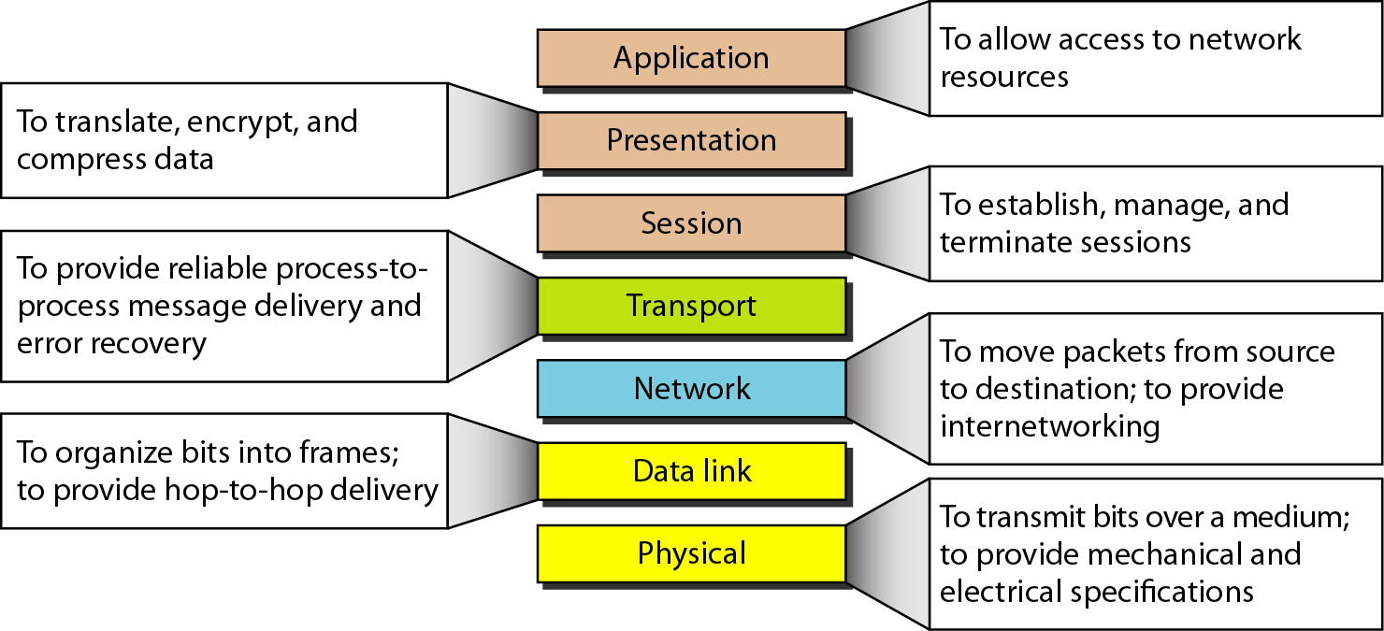

Q5)

- What is the difference between routing and switching? [4 Marks]
Routing is based upon IP addresses. Switching is based upon hardware MAC address.
- Briefly explain physical addresses, logical address and port addresses in TCP/IP
[6 Marks]
Physical addresses
The physical address, also known as the link address, is the address of a node as defined by its LAN or WAN. It is included in the frame used by the data link layer. It is the lowest-level address. The physical addresses have authority over the network (LAN or WAN). The size and format of these addresses vary depending on the network. For example, Ethernet uses a 6-byte (48-bit) physical address that is imprinted on the network interface card (NIC).
07:01:02:01 :2C:4B
A 6-byte (12 hexadecimal digits) physical address
Logical Addresses(IP addresses)
Logical addresses are necessary for universal communications that are independent of underlying physical networks. Physical addresses are not adequate in an internetwork environment where different networks can have different address formats. A universal addressing system is needed in which each host can be identified uniquely, regardless of the underlying physical network. The logical addresses are designed for this purpose. A logical address in the Internet is currently a 32-bit address that can uniquely define a host connected to the Internet. No two publicly addressed and visible hosts on the Internet can have the same IP address.

Port Address
The IP address and the physical address are necessary for a quantity of data to travel from a source to the destination host. However, arrival at the destination host is not the final objective of data communications on the Internet. A system that sends nothing but data from one computer to another is not complete. Today, computers are devices that can run multiple processes at the same time. The end objective of Internet communication is a process communicating with another process. For example, computer A can communicate with computer C by using TELNET. At the same time, computer A communicates with computer B by using the File Transfer Protocol (FTP). For these processes to receive data simultaneously, we need a method to label the different processes. In other words, they need addresses. In the TCPIIP architecture, the label assigned to a process is called a port address.

- In the TCP/IP protocol suite, what are "well-known" ports, and why are they necessary?
[4 Marks]
Well-known ports are port numbers which are being used by the servers for common Internet applications. For example: well-known port for HTTP servers (web) is port 80, for SMTP servers (e-mail) is port 25, etc. Well-known ports range from 0-255.

- Give the commands that should be issued from the command prompt for following actions. [6 Marks]
- To check the IP configuration of a PC
- To check the connectivity between server to
- To remove the obtained IP address
- To obtain a new IP address
- To take the IP address of google.com site
- To take name server of 172.19.10.35

  - To check the IP configuration of a PC - ipconfig
  - To check the connectivity between server to PC- ping <<IP address of the other machine>>
  - To remove the obtained IP address- ipconfig /release
  - To obtain a new IP address - ipconfig /renew
  - To take the IP address of google.com site- nslookup google.com
  - To take name server of 172.19.10.35- nslookup 172.19.10.35
Q6)
- Briefly explain two parts of the IP address. [4 Marks]
Host ID
Identifies a workstation, server, router or other TCP/IP host within a network. Host ID must unique to the network ID
Network ID
Identify a physical network. All hosts on the same network require the same network ID, which should be unique to the internet work
- What is IPv4 and IPv6 ? [2 Marks]
Every machine that is on a TCP/IP network (a local network, or the Internet) has a unique Internet Protocol ( IP ) address.IPV4 and IPV6 are IP address versions.
IP Version 4 (IPv4)
IPv4 uses 32-bit (four-byte) addresses. IPv4 addresses are usually written in dot-decimal notation, which consists of the four octets of the address expressed in decimal and separated by periods. Eg :192.0.2.235

IP Version 6 (IPv6)
IPv6 is the newest version of IP. IPv6 is fairly well defined but is not yet widely deployed. IPv6 uses larger addresses (128 bits instead of 32 bits in IPv4) and so can support many more devices on the network.
- If one assigns the IP address 192.168.1.1 to the LAN interface of the device connecting to the service provider, and 192.168.1.100 to the server, what are the entries for the subnet mask, the default gateway and preferred DNS used in the TCP/IP configuration of the computers on the LAN? [6 Marks]
Subnet Mask -255.255.255.0
Default Gateway -192.168.1.1
Preferred DNS -192.168.1.100

- Figure A depicts proposed high-level network connectivity diagram of SLIATE with several ATIs. Allocate suitable subnets to each of the ATI local area networks (LANs) and router links. Use the IP blocks 172.16.16.0/24 (for LANs) and 192.168.1.0/28 (for router links). [8 Marks]

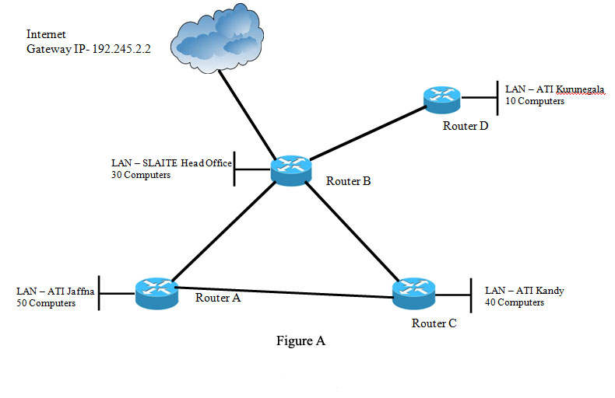

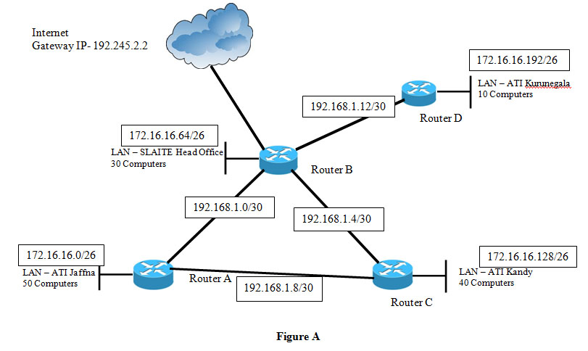
The ATI Jaffna LAN has the maximum number of hosts (50) for a LAN. Therefore one subnet should have at least 50 computers. Then the subnet size would be 64 hosts.

Subnets for the LANs:
ATI Jaffna: 172.16.16.0
SLIATE head office: 172.16.16.64
ATI Kandy: 172.16.16.128
ATI Kurunegala: 172.16.16.192

Subnets for the router links:
Between A and B: 192.168.1.0/30
Between B and C: 192.168.1.4/30
Between A and C: 192.168.1.8/30
Between B and D: 192.168.1.12/30

Note: Give marks for other reasonable answers

Q7)

- Explain how the Domain Name System (DNS) allows a large number of DNS lookups to be processed. [4 marks]

The DNS is managed hierarchically. Rather than gathering all name/IP address pairs in a single place, each domain manages its own pairs. If a name is outside the domain, one of the global DNS managers returns the address of a DNS server that can in turn answer the query (or provide a pointer to yet another DNS server).

- What is a Fully Qualified Domain Name (FQDN)? Give an example. [ 4 Marks]
A fully qualified domain name (FQDN) is the complete domain name for a specific computer, or host, on the Internet. The FQDN consists of two parts: the hostname and the domain name. For example, an FQDN for a hypothetical mail server might be “mymail.ati.edu.”. The hostname is “mymail”, and the host is located within the “domain ati.edu.”

- List four Top Level Domains (TLDs). [4 Marks]
- gov
- net
- org
- mil
- com
- edu
- int
- biz

- Assuming that you are using “mail.atiname.sliate.com” for your institute, draw the DNS tree hierarchy for your address by locating your mail server in the hierarchy. [4 marks]

Root
.

.com .net .org .edu/.biz/.......

sliate
atiname

mail
- Assume that you are a network administrator of the computer laboratory. If student complain that although they can “ping” an IP address of a computer located outside of their network, they are unable to access web sites, what may be the most possible cause for this behavior? How would one go about rectifying it? [4 marks]
- DNS entry has not been configured on PCs
- Obtain the address of the DNS server from the ISP and configure it on all the computers

Q8) Network security is mostly achieved through the use of cryptography.
- Briefly explain cryptography.
[4 Marks]
We use the term to refer to the science and art of transforming messages to make them secure and immune to attacks.
Example
Plaintext: HELLO
Ciphertext: KHOOR

- Define followings. [6 Marks]
  - Plaintext and Ciphertext
  - Cipher
  - Key
Plaintext and Ciphertext
The original message, before being transformed, is called plaintext. After the message is transformed, it is called ciphertext. An encryption algorithm transforms the plaintext into ciphertext; a decryption algorithm transforms the ciphertext back into plaintext. The sender uses an encryption algorithm, and the receiver uses a decryption algorithm.

Cipher
We refer to encryption and decryption algorithms as ciphers. The term cipher is also used to refer to different categories of algorithms in cryptography.

Key
A key is a number (or a set of numbers) that the cipher, as an algorithm, operates on.

- What are the two categories of cryptography algorithms? Briefly explain it. [6 Marks]
  - Symmetric key- secret key
In symmetric·key cryptography, the same key is used by the sender (for encryption) and the receiver (for decryption).The key is shared.

  - Asymmetric key –public key
In asymmetric or public-key cryptography, there are two keys: a private key and a public key. The private key is kept by the receiver. The public key is announced to the public.

- What is meant by firewall? [4 marks]
A firewall is a device or set of devices designed to permit or deny network transmissions based upon a set of rules and is frequently used to protect networks from unauthorized access while permitting legitimate communications to pass. Many personal computer operating systems include software-based firewalls to protect against threats from the public Internet. Many routers that pass data between networks contain firewall components and, conversely, many firewalls can perform basic routing functions

END.

